1. **Create a file and add executable permission to all users (user, group and others)**

>> touch sample1

>> ls -lrt

>> chmod +755 sample1

>> ls -lrt

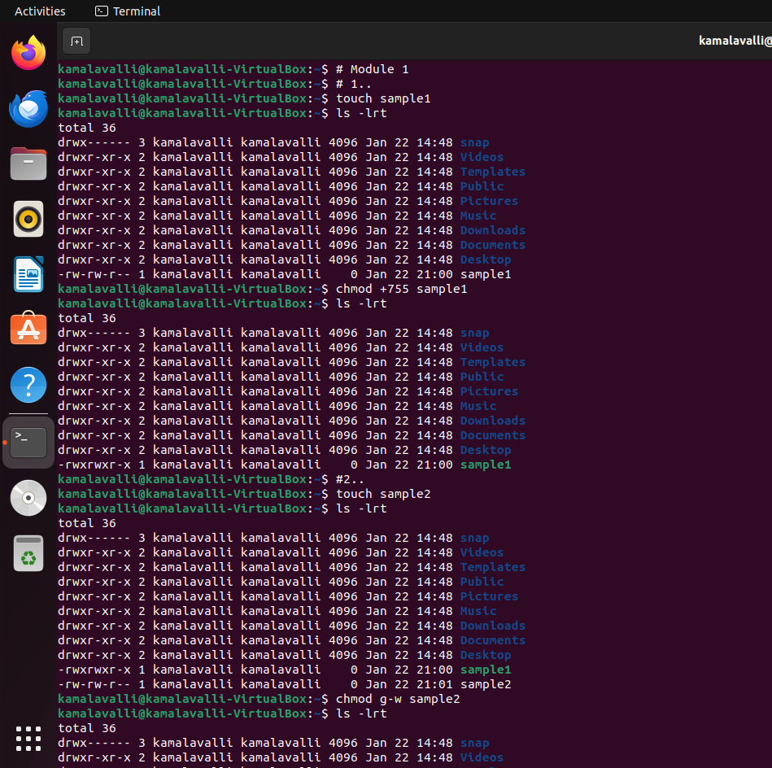

**2) create a file and remove write permission for group user alone.**

>> touch sample2

>> ls -lrt

>> chmod g-w sample2

>> ls-lrt



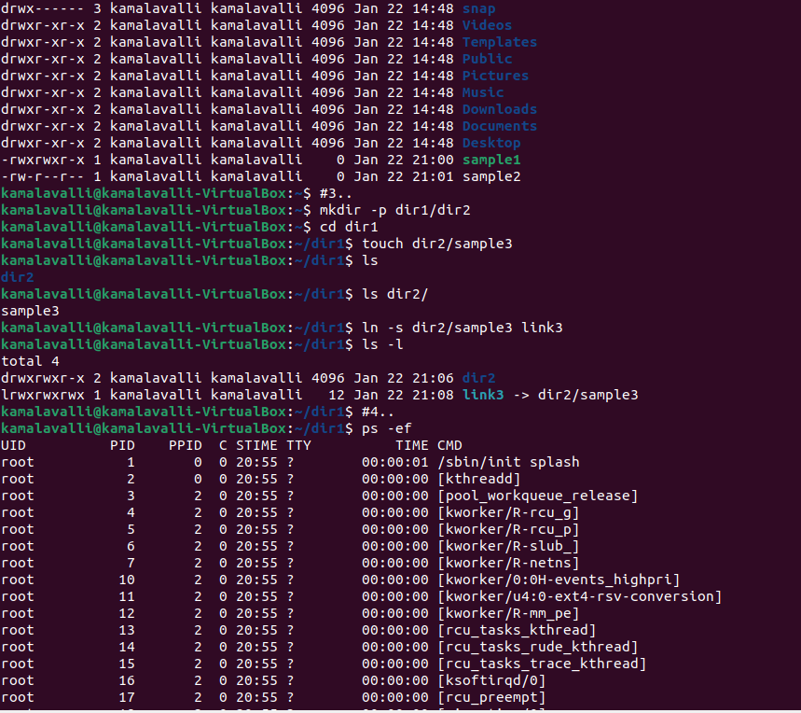

**3) Create a file and add a softlink to the file in different directory (Eg : Create a file in dir1/dir2/file and create a softlink for file inside dir1)**

>> mkdir -p dir1/dir2

>> cd dir1

>> touch dir2/sample3

>> ls

>> ln -s dir2/sample3 link3

>> ls -l



**4) Use ps command with options to display all active process running on the system**

>>  ps -ef



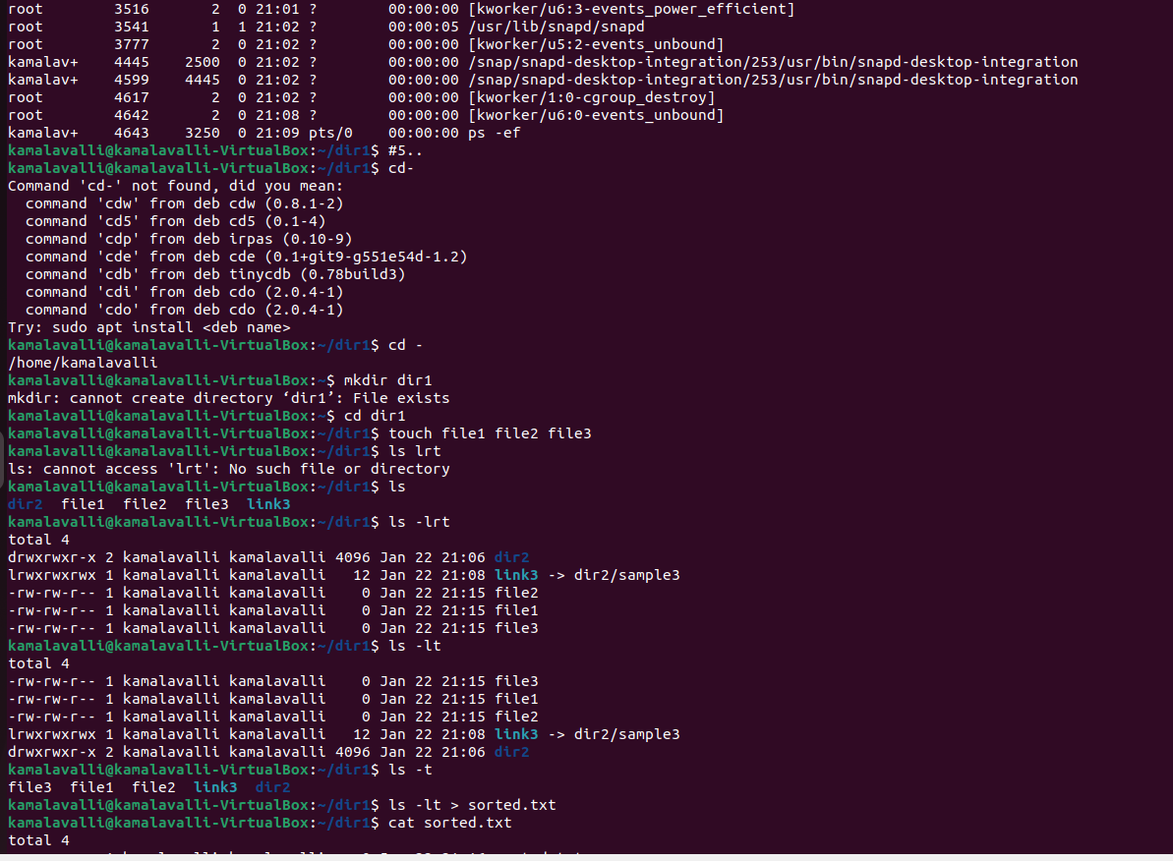

**5) Create 3 files in a dir1 and re-direct the output of list command with sorted by timestamp of the files to a file**

>> cd dir1

>> touch file1 file2 file3

>> ls -lrt

>> ls -lt

>> ls -lt > sorted.txt

>> cat sorted.txt



